PROJECT 003

Software Installation
& Troubleshooting
Practical Windows Application Management

1. Objective
To explore Windows application management and understand how to inspect installed applications, review their settings and permissions, and identify basic troubleshooting options using Windows Settings.

2. Activities Performed
- Opened Windows Settings and navigated to Apps > Installed apps.
- Reviewed the installed applications list, which displayed 64 installed applications.
- Selected and inspected Microsoft Calculator, Clock, Camera and Microsoft Teams.
- Reviewed available application information, including publisher, version, storage usage, permissions and background activity settings where shown.
- Opened Microsoft Calculator's Advanced options and examined Terminate, Repair, Reset and Uninstall.

3. Evidence: Installed Applications
The Installed apps page displayed 64 applications. Calculator, Camera and Clock were visible near the top of the alphabetical list.
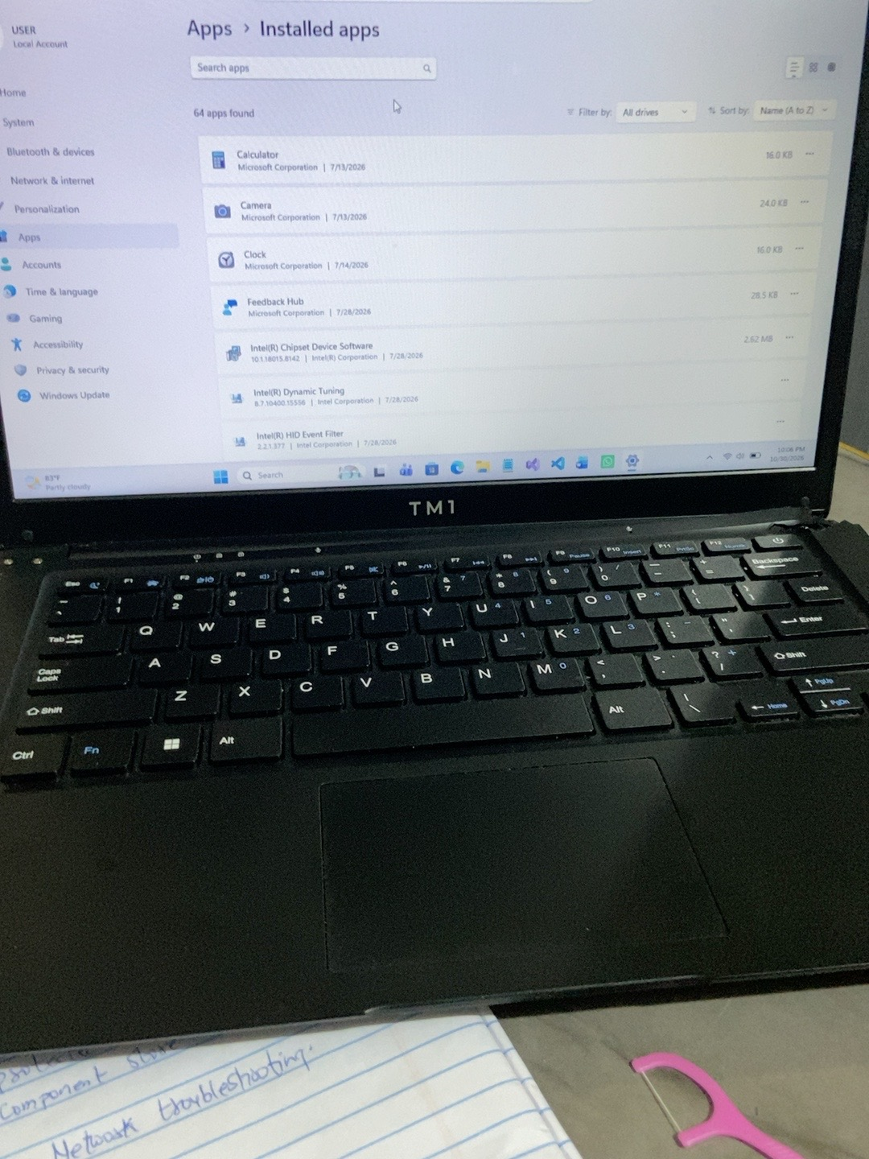
Figure 1. Windows Settings showing the Installed apps list and 64 apps found.

4. Application Inspection

4.1 Microsoft Calculator
Calculator was inspected through its application details page. The screenshot shows Microsoft Corporation as the publisher, version 11.2605.9.0, and the displayed app and data storage information. Its background permission was set to Power optimized (recommended). The Advanced options page was also reviewed.
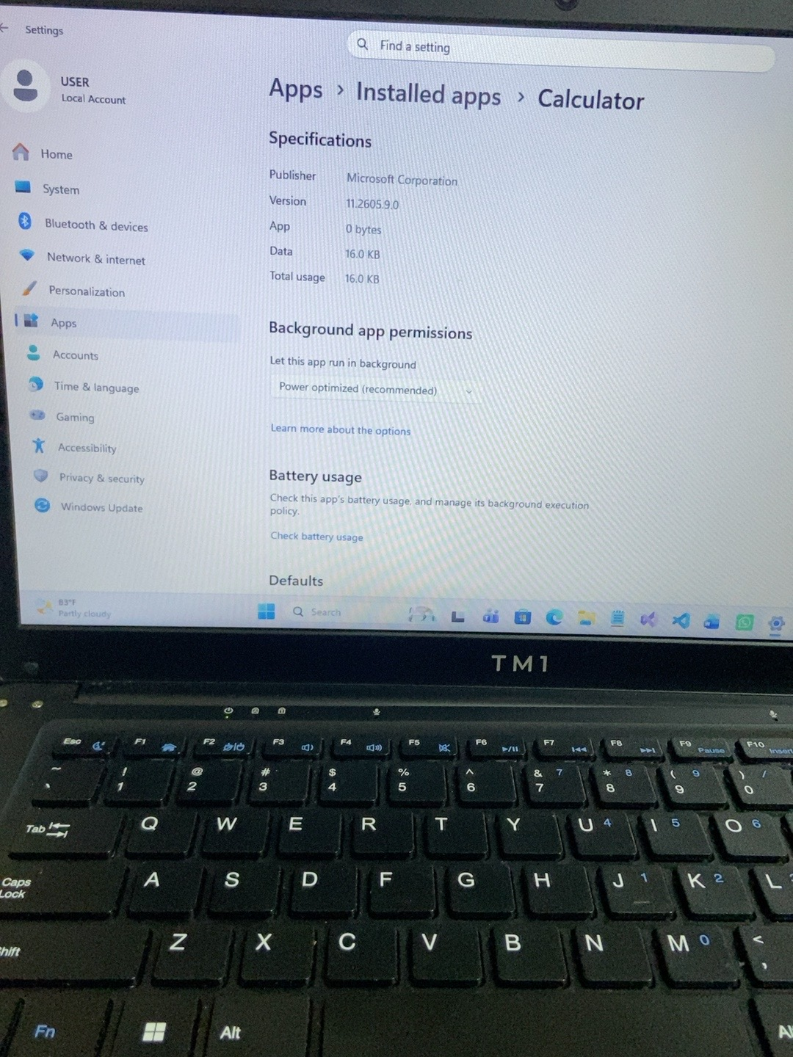
Figure 2. Microsoft Calculator specifications and background app permission.
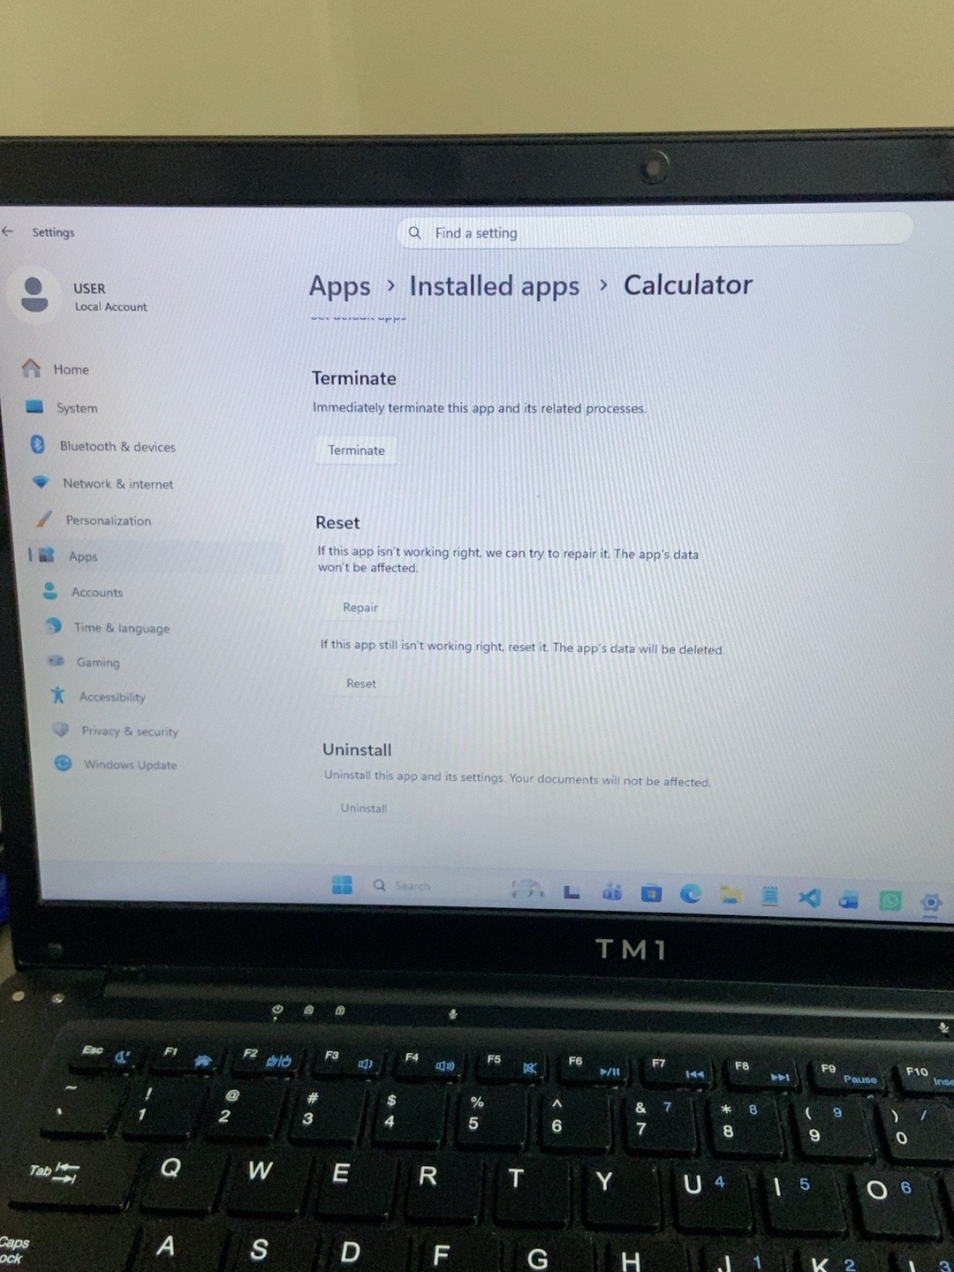
Figure 3. Microsoft Calculator Advanced options, including Terminate, Repair, Reset and Uninstall.

4.2 Clock
The Clock application details showed Microsoft Corporation as the publisher and version 1.1.146.0. The displayed data usage was 16.0 KB, and background activity was set to Power optimized (recommended). During the practical check, the app also displayed a message indicating that it needed an update but could not apply it at that time, and prompted the user to connect to the Internet and try again.
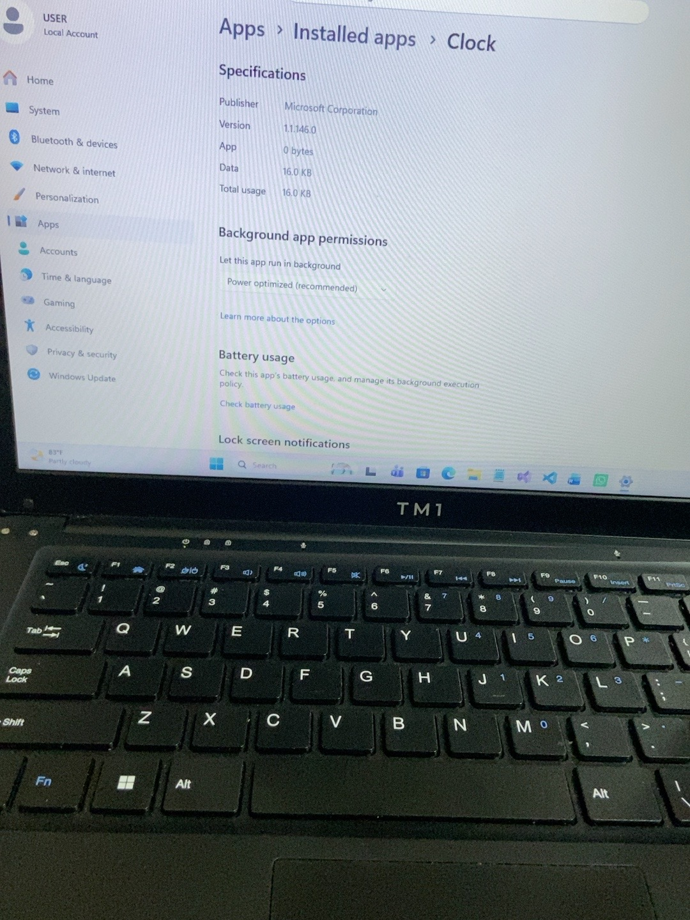
Figure 4. Clock application specifications and background app permission.
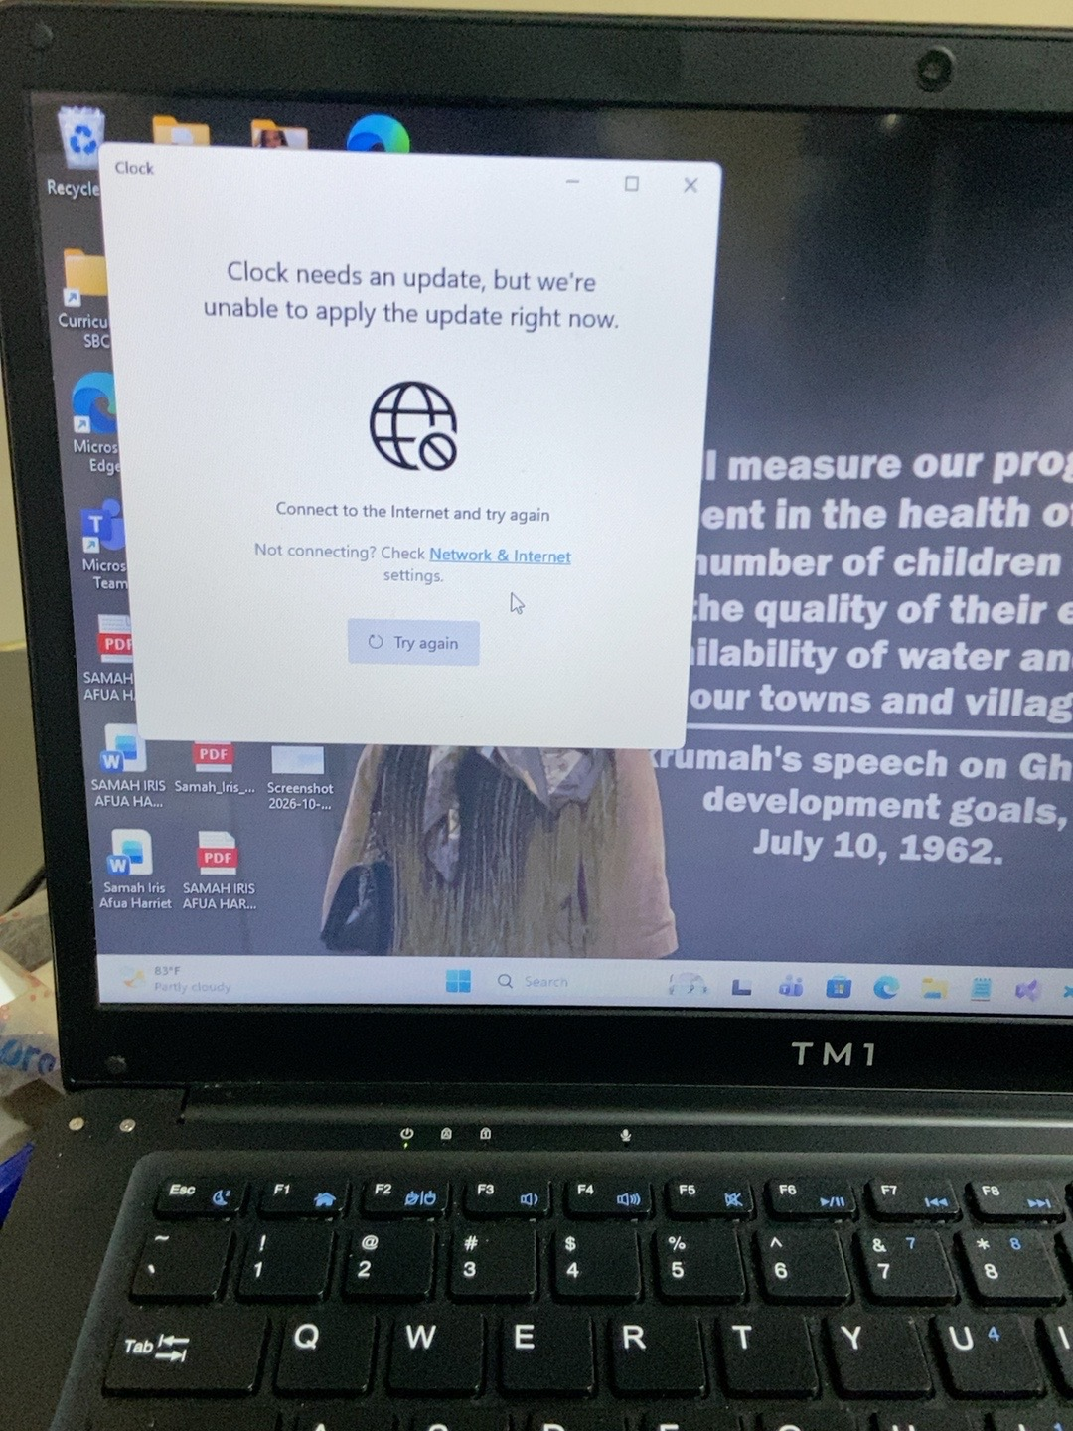
Figure 5. Clock displayed an update message and requested an Internet connection.

4.3 Camera
The Camera application details showed Microsoft Corporation as the publisher and version 2026.2605.7.0. The displayed data usage was 24.0 KB. In the permissions section, Location was Off, while Camera, Microphone, Pictures and Videos permissions were On.
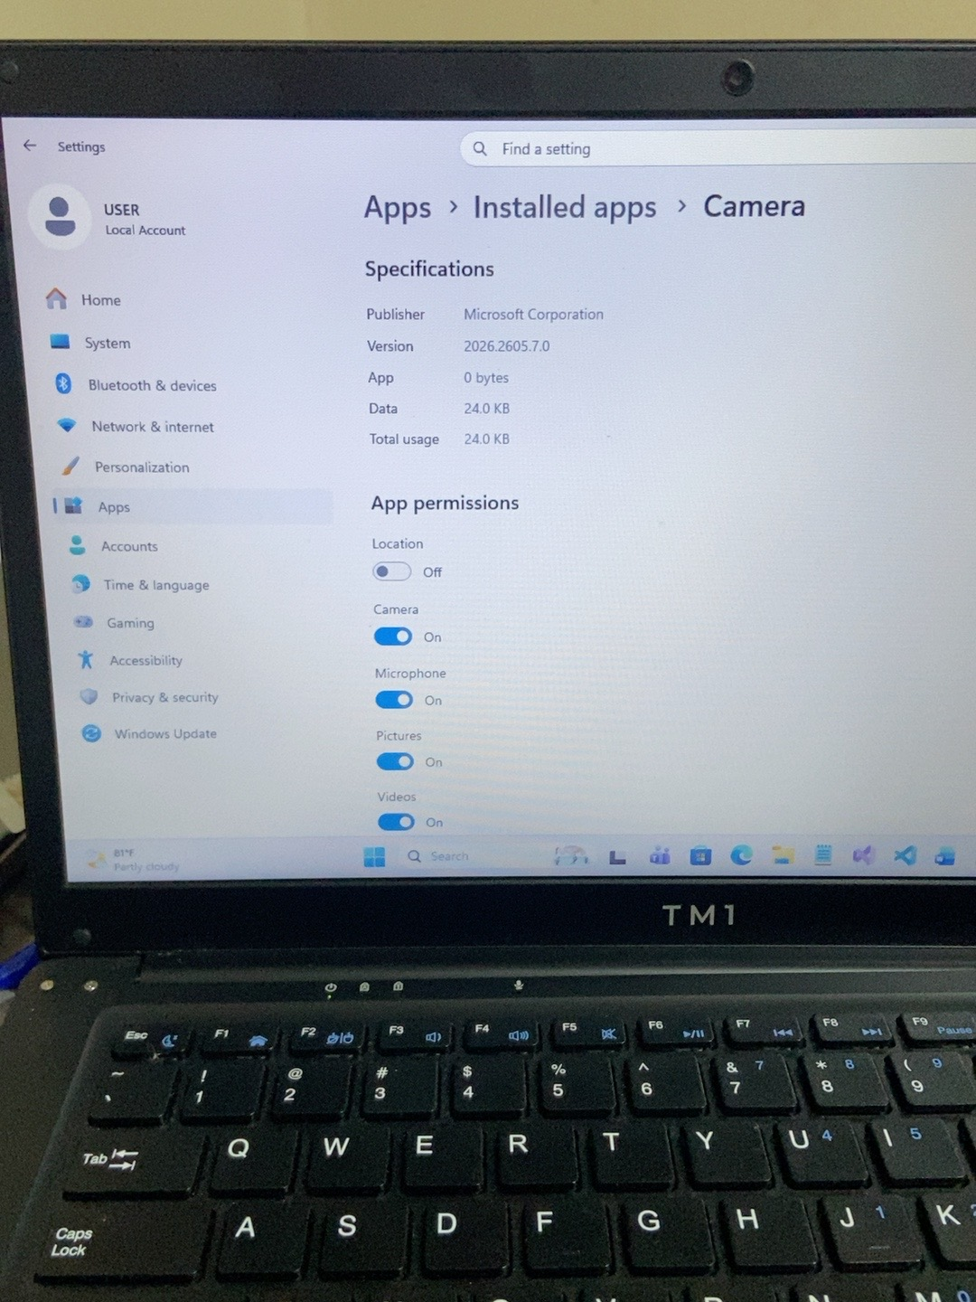
Figure 6. Camera application specifications and permissions.

4.4 Microsoft Teams
The Microsoft Teams application settings were inspected. The screenshot shows its background app permission set to Power optimized (recommended). The option controlling whether Microsoft Teams runs at sign-in was Off.
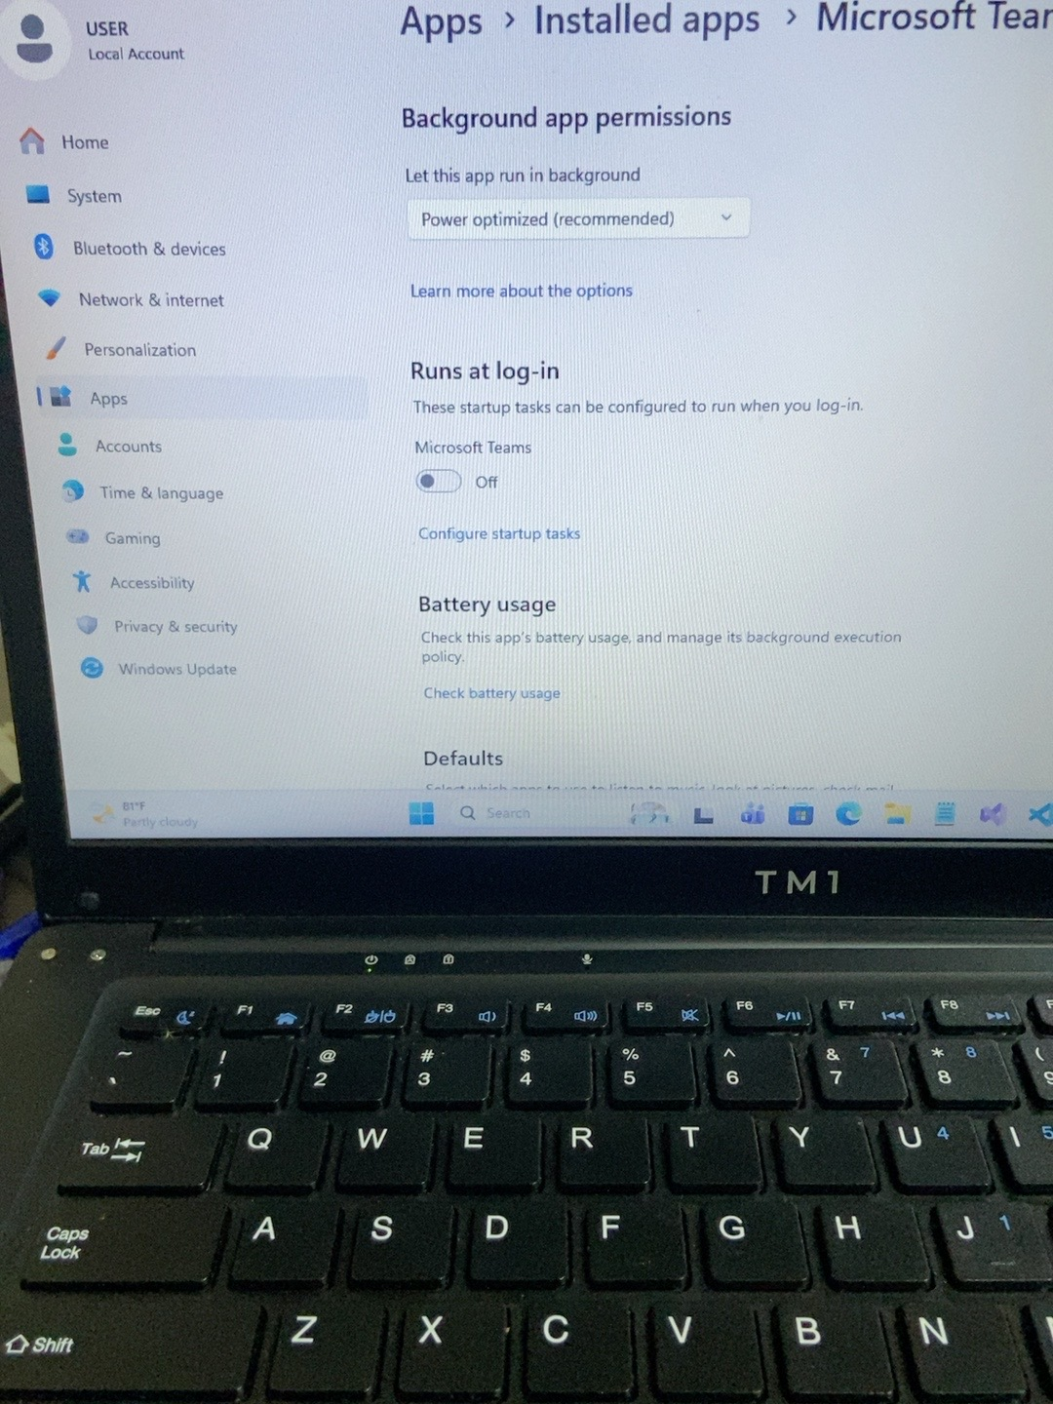
Figure 7. Microsoft Teams background permission and run-at-log-in setting.

5. Findings
Windows Settings provides a central location for reviewing installed applications and managing selected app settings. The inspection demonstrated that application details can include publisher, version, storage usage, permissions, background activity and startup behaviour. The Clock app's update message also demonstrated how an application may report a problem that requires an Internet connection.
Option | Purpose
Terminate | Immediately stops the application and its related processes.
Repair | Attempts to fix the application without deleting its stored data.
Reset | Restores the application to its default state and deletes its stored data.
Uninstall | Removes the application from the computer.
The Calculator options were inspected for learning purposes. No repair, reset or uninstallation action was performed as part of this exercise.

6. Conclusion
This project provided practical experience in managing installed Windows applications and reviewing their settings. It improved familiarity with Windows Settings, application permissions, background activity, startup behaviour and basic troubleshooting options.

